Blackjack
Software Design Document

Manny Gonzales, Nick Vu, Paul Cooper
https://github.com/eb-heavybarrel/CS401_Blackjack
Revision History

Date | Revision | Description | Author
03/04/2026 | 1.0 | Initial Version | Nick Vu
04/07/2026 | 1.1 | Fixed page numbers. Section 1 cleaned up including removing requirements. Started on Architecture section (section 2), updated TOC. | Paul Cooper
04/07/2026 | 1.2 | Section Arrangement and Content Changes | Nick Vu
04/07/2026 | 1.3 | Section 3 Additions | Nick Vu
04/08/2026 | 1.4 | Updated most of section 2 | Paul Cooper
04/08/2026 | 1.5 | Section 3 Updated/Complete | Nick Vu

Table of Contents
1. Introduction iv
1.1. Scope iv
1.1. Definitions, Acronyms, Abbreviations iv
1.2. Overview v
2. Architecture vi
2.1. Overview vi
2.2. Networking vi
2.3. Messaging vi
2.4. Server vi
2.5. Client vi
3. System Interface Design viii
3.1. Application Overview viii
3.1.1. Design Outlook viii
3.2. GUI Diagrams viii
3.3. Layout and Structure viii
4. Use-Cases and Common Flows ix
4.1. Use-Case Diagrams ix
4.2. Sequence Diagrams ix
4.3. Common & Intended User Interfacing Flow ix

Introduction
This software design document provides a architectural overview for the Blackjack Handling System (BHS).

Scope
This document will catalog the user, system, and hardware requirements for the BHS system. It will not, however, document how these requirements will be implemented.

Definitions, Acronyms, Abbreviations
Player: A user role that can participate in Blackjack games, and participate in standard game actions such as betting, hit, stand, and folding/surrendering
Dealer: A specialized user role with the added ability to operate as a dealer for the games and the configurator of game parameters when creating joinable tables for blackjack, deals cards in accordance to standard blackjack rules
User: Either a player or a dealer, generally used before the system has identified the individual during the login phase.
Hand: A collection of cards assigned to a player or dealer during a round of Blackjack, which changes based on gameplay actions and outcomes
Table: The instance of a game in a lobby, up to six players including the hosting dealer
Lobby: An area of the Blackjack program where tables are viewable for players to join or for dealers to create a table
Round: A cycle of player betting and playing in a blackjack game between the betting and outcome phases
Game phase: Distinct phases for player betting, dealing and actions, and outcome
Payout: A specific outcome for a player to be paid out the appropriate bet they won against the dealer
Deck: A standard set of 52 cards used to interact with the gameplay
Card: A singular card from a standard deck of 52 cards, categorized by suit and rank value
Shoe: A collection of multiple decks used in the Blackjack games
Bet: A number of credits submitted by a player before being dealt hands to start playing the game
Timer: A countdown for the time players have to take action in a round of the game
Credits: Virtual currency with a 1-to-1 conversion with player dollars from their payment method attached to their account, used in bets for games
Blackjack Handling System (BHS): The software responsible for handling the blackjack game functions and logic, network connectivity for players to the server, as well as player interactions and active games
Graphical User Interface (GUI): The visual interface players use to interact with the BHS
Server: The program responsible for allowing multiple client programs to connect, allowing users to play blackjack games against each other over a network connection, receives player actions and enforces game rules with network communication between clients
Client: The program used by players to connect to the server program for connection to blackjack games over a network connection, sends actions to the server
Soft hand: When a player or dealer has an ace whose current value is 11. Standard blackjack rules require the dealer to hit when they have a soft 17 or less.
Hit: When a player requests an additional card from the dealer.
Stand: When a player signals they don’t want any additional cards dealt to them during the current round.
Double down: When a player asks for one more card to be dealt to them that round while also doubling their current bet.
Split: When a player has matching cards, they can pay to have their hand divided into two separate hands. The dealer will then deal each hand an additional card to bring the total cards in each hand to two.
Bust: When the hand value of either the player or the dealer goes above 21, resulting in an automatic loss.
Push: When the dealer and the player end the round with the same hand value and all bets are returned.
Win: When the player ends the round with a higher hand value than the dealer.
Lose: When the player ends the round with a lower hand value than the dealer, or they bust.
Insurance: When a dealer is showing an ace in their hand, the players are offered the option to pay 50% more to protect their hands. If the dealer does have a blackjack, the bets are returned to the players that opted for insurance. If the dealer does not have a blackjack, the additional money goes to the house.
House: the organization the dealer works for. All bets are either covered by the house if the dealer loses or paid to the house if the player loses.
Shuffling: when the order of the cards in the shoe are randomized.

Overview
The Blackjack Handling System is designed to facilitate multiplayer games of Blackjack. Live user incorporating both players and dealers. Each dealer hosts a table with players opting to join their preferred tables to play blackjack.

Architecture

Overview
The system will be organized into several major elements. Of note are the Server and Client which between them contain all other elements in the application. Some elements are shared between them, such as the networking and messaging pieces. While they are both similar, there will be slight differences between the network piece on the server and the network piece on the client. Likewise, the messaging elements will contain many similarities but with some important differences to facilitate game play and other functionality within the application.
As the shared functionality between the Server and client are critical, so are the elements that are unique to each component. The server will need to manage player and dealer accounts, in-game processes across multiple concurrent games, and facilitating game matching, giving the user the choice of games to join. The client will need to display all this information to the players or dealers across multiple screens.

Networking
Since this is a client-server application, a multithreaded network design will be implemented for both clients and server. The clients will need the ability to send and receive messages to and from the server to handle game mechanics while the server will need additional capabilities to be able to handle multiple clients simultaneously.

Messaging
The messaging component will handle the actual communication between the server and clients. Serialized content will be passed back and forth between the server and client through the networking component. Each message will be tailored to a specific task, such as handling the login and log-off sequences, the ability to add and remove funds from the players account, and most importantly the in game messages that must be passed back and forth to facilitate the correct sequence of events needed in order to choreograph player and dealer actions for smooth in-game mechanics.

Server
The server manages the bulk of the workflow. As mentioned, it requires the networking and messaging components to manage the back-and-forth communications between the clients and the server including indirect communications between clients so that all players at a table can see any updates any one player makes. To accomplish this the server must also manage the following components.

2.4.1: Data

Data management primarily allows for continued game operations between server reboots. To make file management easier we plan to create one file per user. Since usernames will be unique across the application, we can generate a csv file in the format <username>.csv. Since we can access the username from the file itself, we only need to store the user’s password, access level (player, dealer, or developer), and the current credits in their account. While the user’s password and access level rarely change, the credits in the account will be constantly changing while a user is playing the game. Having a separate file per user will allow us to modify multiple files simultaneously instead of having to queue up multiple requests to modify a single file every time a request to update a player’s credits is requested.
In addition to player state files, a server state file will be generated to manage data such unique ID numbers that should never be reused across server reboots. The use of these IDs will allow us to also log data on a per table basis to assist in troubleshooting during development.

2.4.2: Account

Account data will include a username, password, access level, and current account credits. This data will be stored in memory during active sessions but will also be written to file one every change to allow for seamless continuation between server reboots. Players will have the ability to create their accounts using the client application. While dealers and developers can also use the client to create their accounts, permissions for these accounts must be set manually by modifying the user files directly. To prevent access violations, these changes should be made between server reboots.

2.4.3: Table

Each table will be given a unique ID. It will also have a unique dealer, and a list of payer ID that can constantly change ass players join and leave the table. Each table will have specific in-game settings that the dealer sets up as the table is created. These include the minimum and maximum bets, the game timer that limits how long each play has to perform an action during their turn, and the number of decks the shoe will contain for that table.

2.4.4: Game

The game will contain the shoe. Depending on how many decks the shoe contains, it will start with a shuffled list of cards equal to the number of decks times 52. The cards are dealt one at a time to each player as called for depending on the current in-game state and player or dealer requests. When a card is dealt, it is removed from the shoe and added to one of the active hands. One the round is completed, all cards in any hand are discarded and a new set of cards is dealt from the shoe. When the shoe has only 60 cards remaining in it, the current round of hands is completed and then all discarded cards are returned to the shoe and the shoe is shuffled.
Each round will keep track of each player’s current hand(s) along with the dealer’s hand. It also keeps track of the current hand-in-play and a timer that prevents any one player from taking up too much time. This prevents the game from stalling and provides an expected flow to the game that players are comfortable with.
Other considerations must also be made for exceptions. For example, if the timer expires during a player’s turn it is assumed the player is standing for that round. The same applies if the player leaves a game in the middle of a round. If the dealer needs to leave the table, we need to notify all players at the table that the table will close at the completion the round, at which point the players will be returned to the lobby.

Client
Java based client/server application with no web interfaces.
All participants must have network access configured to allow them to communicate with the server.
The server must have network access configured to allow it to communicate with the clients.

System Interface Design

Application Overview
The Blackjack Handling System (BHS) client provides a graphical user interface (GUI) that enables users to interact with the system across all stages of usage, including authentication, lobby navigation, and active gameplay. The GUI is designed to be intuitive, responsive, and role-aware, dynamically adapting available controls and information based on whether the user is a player or dealer.
The application is structured around three primary interface environments:
- Login Interface – Handles authentication and account creation
- Lobby Interface – Provides table discovery, system navigation, and account management
- Table Interface – Facilitates real-time blackjack gameplay and interaction
Each interface operates as a distinct view while maintaining continuity through consistent layout structure and navigation paradigms.

Design Outlook

The design philosophy of the BHS GUI prioritizes clarity, responsiveness, and rule-driven interaction. The interface is built around the following principles:

- Role-Based Adaptation
The GUI dynamically adjusts available controls and views depending on whether the user is a player or dealer. This ensures users only see relevant actions and reduces complexity during interaction.

- State-Driven Interaction
Interface components reflect the current game phase (betting, action, outcome). Buttons and actions are enabled or disabled in accordance with game rules enforced by the server.

- Real-Time Feedback
The client continuously reflects updates from the server, including player actions, card dealing, bet changes, and round outcomes.

- Consistency Across Views
Shared UI patterns (navigation placement, panel usage, information grouping) are maintained across all screens to minimize learning overhead.

- Scalability of Display Elements
Interface regions such as player hands and table rosters dynamically scale to accommodate varying numbers of players and cards.

GUI Diagrams
The GUI is composed of three primary screens, each corresponding to a major functional stage of the system.

3.2.1 Login Screen
The login screen serves as the entry point into the system and is responsible for user authentication and account creation.
    - Users input required credentials to connect to the server
    - The same interface supports both login and account registration
    - Minimalist design reduces friction and focuses on primary actions
This interface ensures secure access to the system before any gameplay or interaction occurs:

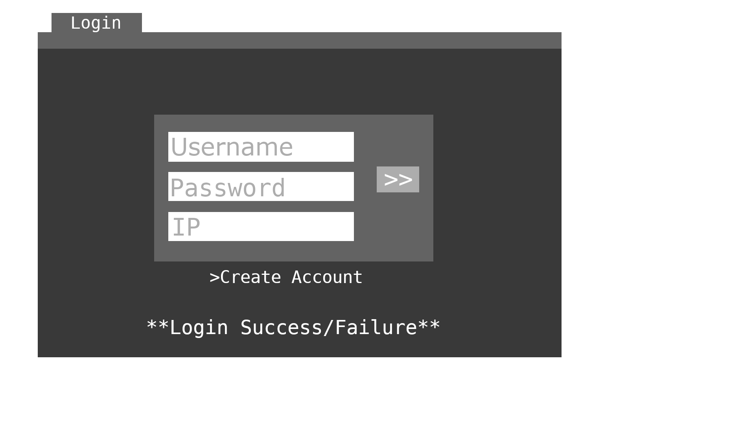

3.2.2 Lobby Screen

The lobby screen functions as the central hub for player interaction outside of active gameplay.
- Displays a list of available tables with relevant metadata (e.g., minimum bet, turn timer, availability)
- Allows players to join tables or navigate to other system features
- Provides access to:
  - Account balance and financial actions
  - Game rules reference
  - Settings and logout functionality
The layout incorporates a panel-based design, where selected options populate a primary viewing area dynamically:
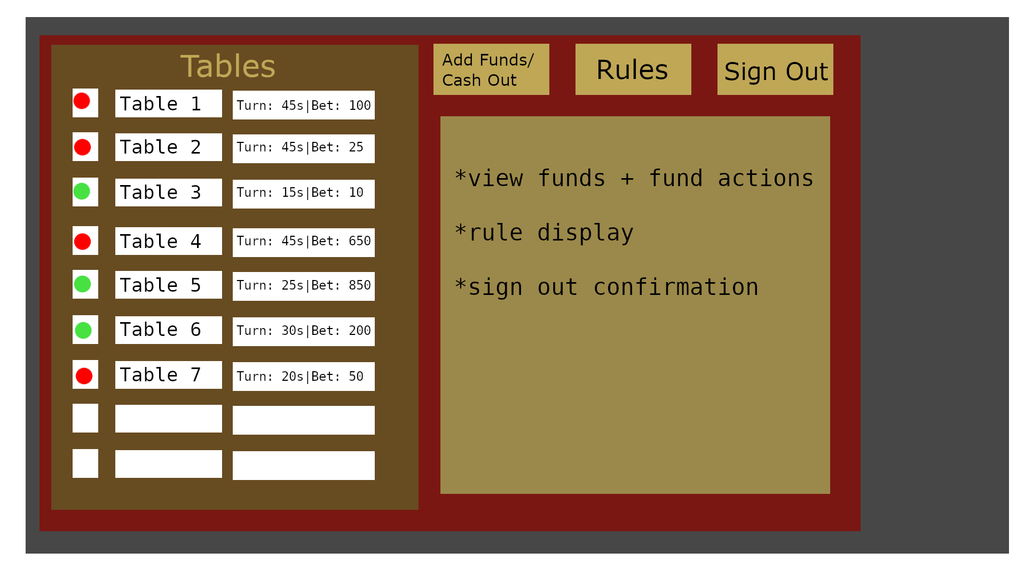

3.2.3 Table/Game Screen

The table screen is the core gameplay interface where blackjack rounds are conducted.
- Displays:
  - Player and dealer hands
  - Current bets and balances
  - Table roster and turn order
  - Game status and phase
- Supports:
  - Player actions (hit, stand, double down, split, insurance, surrender)
  - Dealer controls (deal, take player bets, manage phases, table configuration)
- UI behavior includes:
  - Dynamic enabling/disabling of actions based on rules
  - Visual differentiation of available vs unavailable actions
  - Real-time updates reflecting all player activity
The layout mirrors a real blackjack table, with player positioning indicating turn order and interaction flow. The difference for the dealer-sided flow of logging in is that they will immediately be met with the table screen, first in a settings configuration setup with adjustable parameters, then as a table upon completing the configuration.

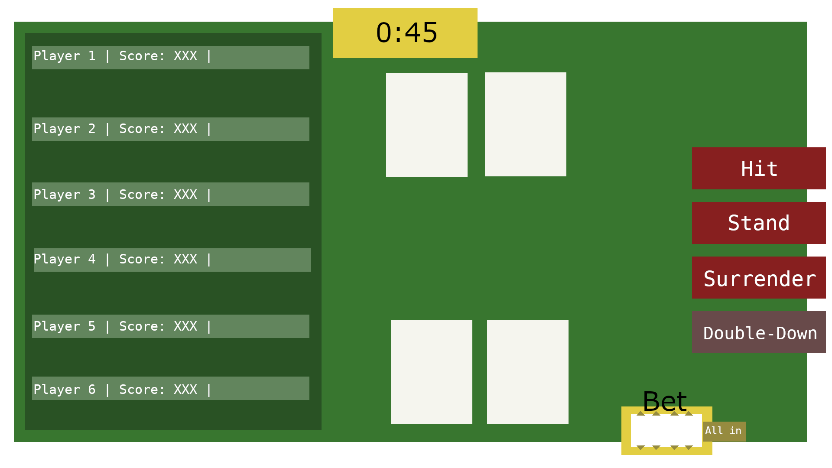

Layout and Structure
The graphical user interface is organized using a modular, panel-based structure that supports dynamic content updates and separation of concerns between different functional areas. Each primary screen (login, lobby, and table) is composed of reusable interface regions that can be updated or replaced without requiring a full screen transition. This allows the client to respond efficiently to real-time updates from the server while maintaining a consistent user experience.
The layout follows a clear information hierarchy to guide user interaction. The central region of each screen is reserved for the primary task: authentication on the login screen, table browsing in the lobby, and gameplay in the table view. Secondary regions are used to display supporting information such as account details, table parameters, or rules. Actionable controls are grouped in consistent locations to reduce user confusion and improve accessibility during time-sensitive interactions.
Within the lobby interface, the layout emphasizes discoverability and navigation. A main display area presents available tables along with key attributes such as player capacity, minimum bet, and turn timer. Additional functionality such as account management, rule viewing, and logout is accessible through surrounding interface elements. The design allows the central panel to be updated dynamically based on user selections without disrupting the overall layout.
The table interface is structured to resemble a real-world blackjack table in both organization and flow. The dealer’s hand is positioned prominently, while player hands are arranged in a consistent order based on when users joined the table. This ordering establishes a clear and intuitive turn sequence. Each player’s betting area is located adjacent to their hand, and action controls are grouped in a dedicated region that updates based on the current game phase.

Use-Cases and Common Flows

Use-Case Diagrams

Sequence Diagrams

Common & Intended User Interfacing Flow
4.3.1

